



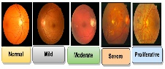

Datasets Fundus Images Preprocessing CNN Backbone Layers

Cross-Patch Attention
No DR
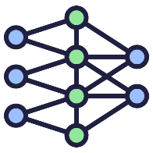
Global Context Attention
Mild DR
Moderate DR
Severe DR
Feature Attention Block
Proliferative DR
Fully Connected Layers
Region Attention Block
Classifier

Attention Block

Proposed Methodology flow Diagram

